Computer Programming  
Lab Tasks



Department of Computer Science - BUIC

**Name: Saad Ahmad**

**Enrollment Number: 01-134222-130**

**Exercises/Lab Journal 9**

**Task 1:** Write a program which asks the user to enter the width and height of a rectangle. Pass these values to a function ‘Area’ to compute the area of the rectangle. Display the area in the function main.

**Code:**

#include <iostream>

using namespace std;

int Area(int h, int w) {

int ar = h * w;

return ar;

}

int main()

{

int x;

int y;

cout << "Enter the height :";

cin >> x;

cout << "Enter the width :";

cin >> y;

cout <<Area(x, y);

return 0;

}

**Ouput:**

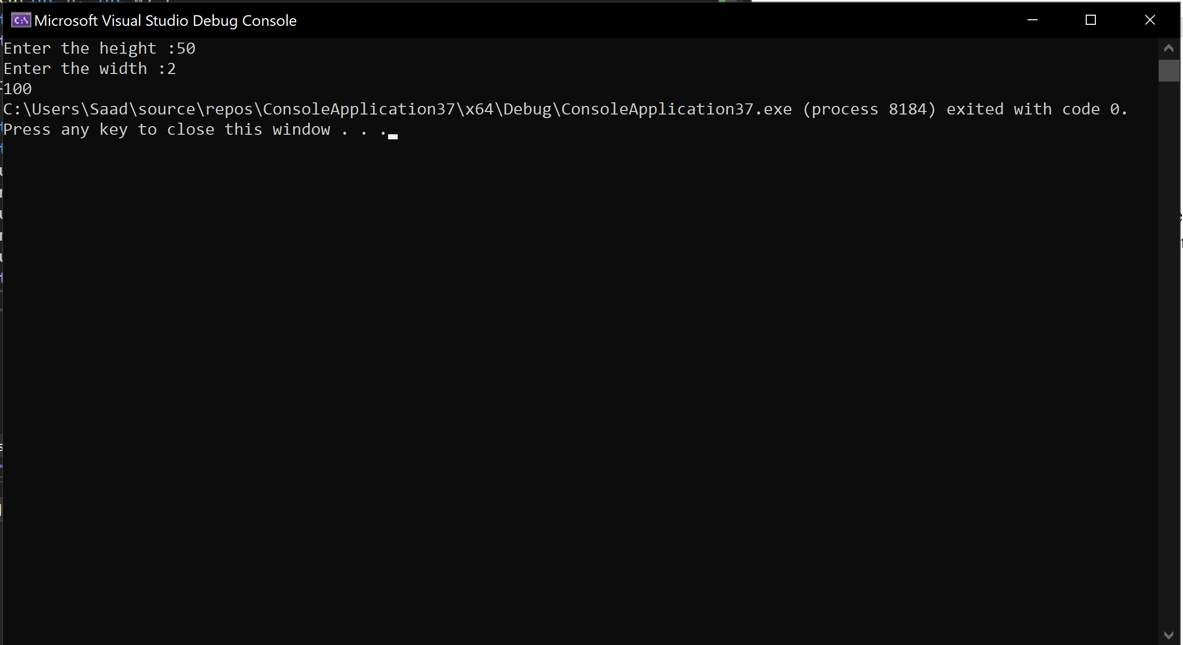

**Task 2:** Write a function that takes two integer arguments and returns the result of dividing the first by the second. The program should not attempt the division if the second number is zero, in this case it should return -1.

**Code:**

#include <iostream>

using namespace std;

float divide(int a, int b) {

float result = 0;

if (b == 0) {

result = -1;

}

else {

result = float(a) / float(b);

}

return result;

}

int main()

{

int x;

int y;

cout << "Enter two numbers" << endl;

cin >> x >> y;

cout << divide(x, y);

return 0;

}

**Output:**

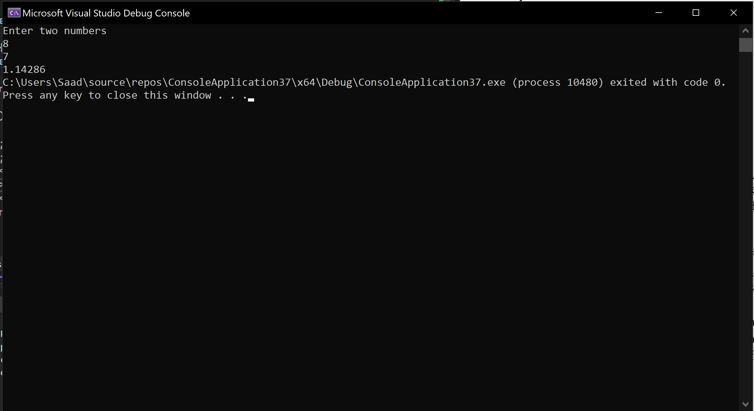

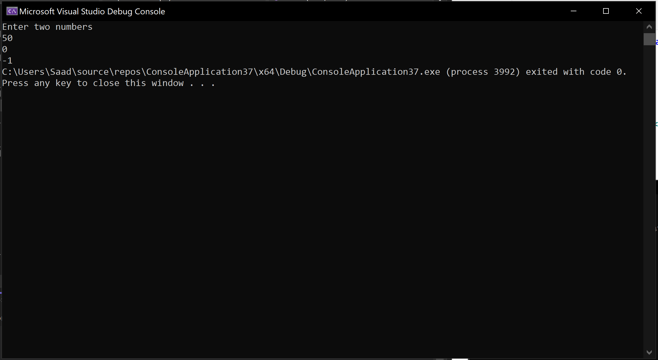

**Task 3:** Write a C++ program with two functions **U_Case( )** and **L_Case( ),** that takes an alphabet from the user and display it in the other case i.e. if the user enters an alphabet in lower case it should call U_Case( ) and convert it to uppercase and then display it and incase the user enters an alphabet in uppercase it should call L_Case().

HINT: You may use functions defined in <cctype> header file. To identify the functions your need, visit following URL (<https://cplusplus.com/reference/cctype/>) and read the documentation. To use the function include following header file #include <cctype>

**Code:**

#include <iostream>

#include <cctype>

using namespace std;

char U_Case(char alph) {

alph = toupper(alph); // toupper is used to convert lowercase letters to uppercase letters

return alph;

}

char L_Case(char alph) {

alph = tolower(alph); // tolower is used to convert upper letters to lowerrcase letters

return alph;

}

int main()

{

char alph;

cout << "Enter an alphabet :";

cin >> alph;

if (isupper(alph)) { // isupper is used to check whether a letter is uppercase or not

cout << L_Case(alph);

}

else if (islower(alph)) { // islower is used to check whether a letter is lowercase or not

cout << U_Case(alph);

}

return 0;

}

**Output:**

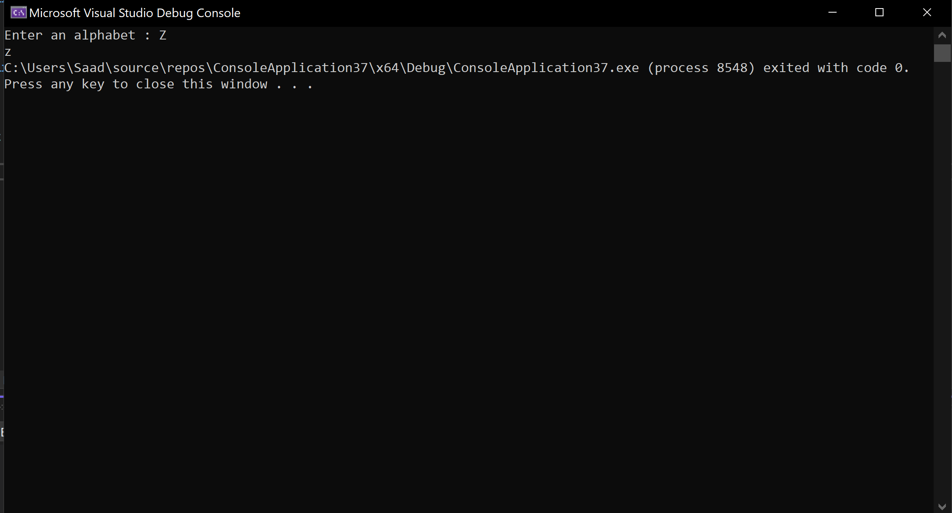

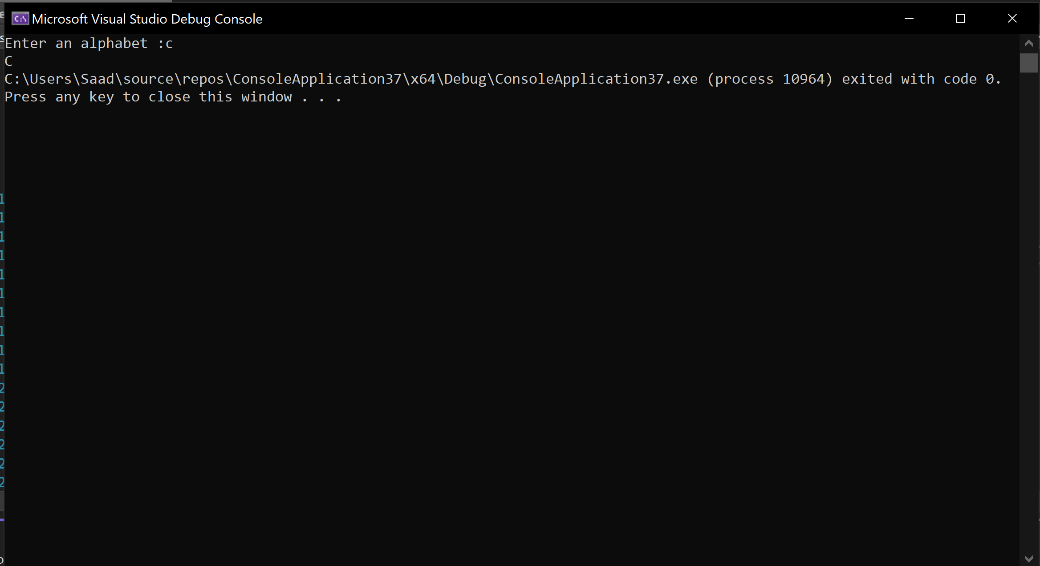

**Task 4:** Define a function totaloccurrences(), which takes two parameters a character array and a character. The function should calculate the total number of occurrences of the character in the array. Call this function in main(). Take the string as input from the user.

**Code:**

#include <iostream>

using namespace std;

int totaloccurrences(char arr[], char check , int size) {

int a = 0;

for (int i = 0; i < size; i++) {

if (check == arr[i]) {

a++;

}

}

return a;

}

int main()

{

const int size = 10;

char arr[size];

char check;

cout << "Enter the characters in the array" << endl;

for (int i = 0; i < size; i++) {

cin >> arr[i];

}

cout << "Enter the character you want to check" << endl;

cin >> check;

cout << check << " appears " << totaloccurrences(arr, check , size) << " time in this array" << endl;

return 0;

}

**Output :**

